**MODUL 5  
ALJABAR BOOLEAN**

**Nama : Auzan Danar Kusuma  
NIM : L200180005  
Kelas : A**

**KEGIATAN PRAKTIKUM**

**Pecobaan 1.**

1. Buat kombinasi gerbang logika sebagaimana pada gambar di bawah ini!

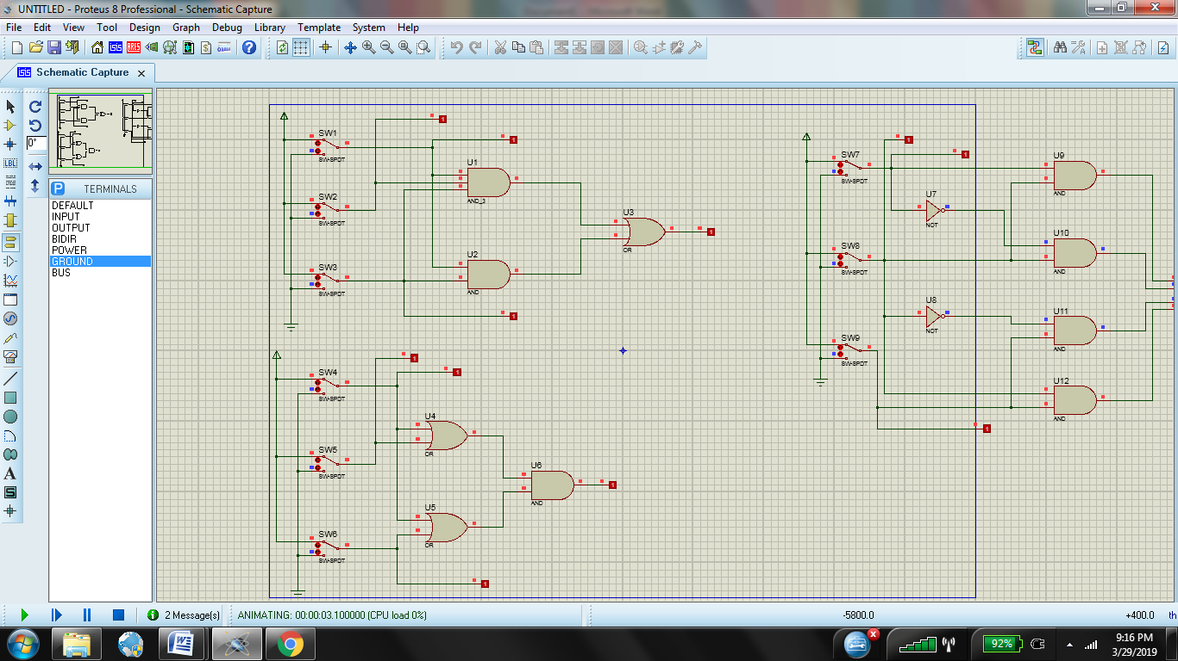

1. Fungsi Boolean : F=AB+A’B+B’C+BC
2. Tabel kebenaran

|  |  |  |  |
| --- | --- | --- | --- |
| A | B | C | F |
| 0 | 0 | 0 | 0 |
| 1 | 0 | 0 | 0 |
| 0 | 1 | 0 | 1 |
| 1 | 1 | 0 | 1 |
| 0 | 0 | 1 | 1 |
| 1 | 0 | 1 | 1 |
| 0 | 1 | 1 | 1 |
| 1 | 1 | 1 | 1 |

d) Karnaugh map

|  |  |  |  |  |  |
| --- | --- | --- | --- | --- | --- |
|  | | AB | | | |
| 00 | 01 | 11 | 10 |
| C | 0 | 0 | 0 | 0 | 0 |
| 1 | 0 | 0 | 1 | 1 |

e) Penyerderhanaan Fungsi Boolean :   
F=BC

**Percobaan 2.**

1. Buat kombinasi gerbang logika sebagaimana pada gambar di bawah ini!

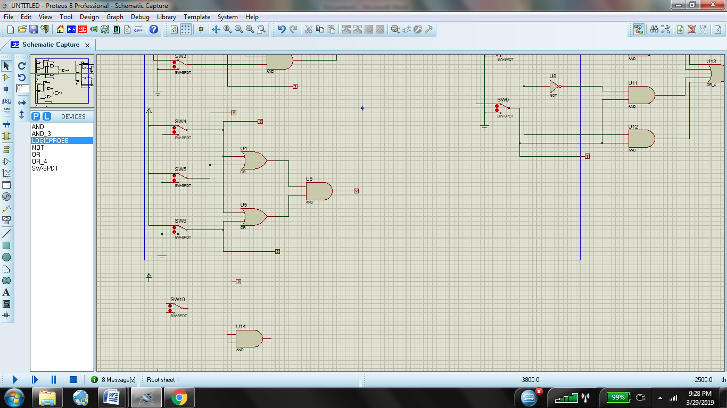

1. Fungsi Boolean : F=ABC+AC
2. Tabel kebenaran

|  |  |  |  |
| --- | --- | --- | --- |
| A | B | C | F |
| 0 | 0 | 0 | 0 |
| 1 | 0 | 0 | 0 |
| 0 | 1 | 0 | 0 |
| 1 | 1 | 0 | 0 |
| 0 | 0 | 1 | 0 |
| 1 | 0 | 1 | 1 |
| 0 | 1 | 1 | 0 |
| 1 | 1 | 1 | 1 |

d) Karnaugh map

|  |  |  |  |  |  |
| --- | --- | --- | --- | --- | --- |
|  | | AB | | | |
| 00 | 01 | 11 | 10 |
| C | 0 | 0 | 0 | 0 | 0 |
| 1 | 0 | 0 | 1 | 1 |

e) Penyerderhanaan Fungsi Boolean :   
F=AC

**Percobaan 3.**

1. Buat kombinasi gerbang logika sebagaimana pada gambar di bawah ini!

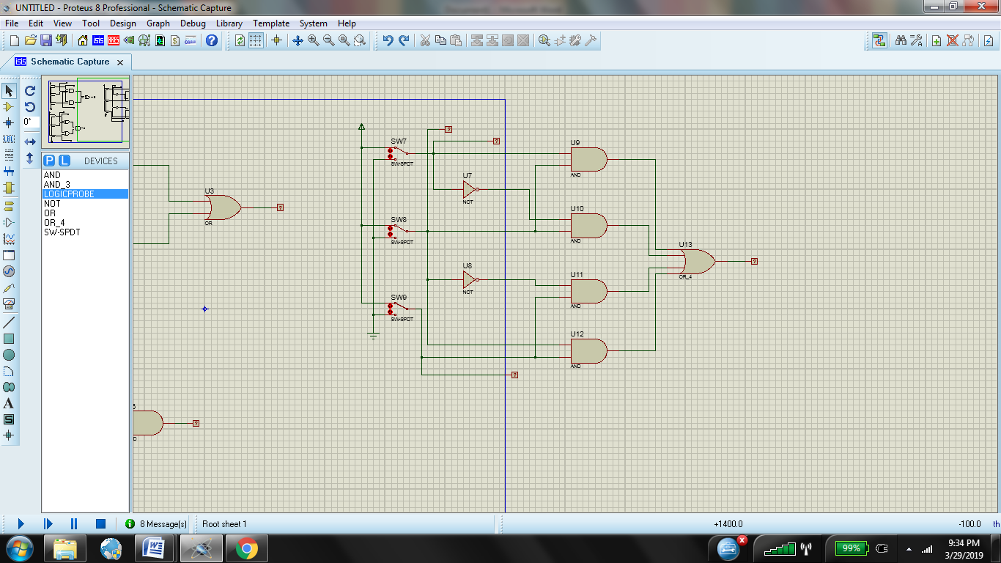

1. Fungsi Boolean : F=AB+A’B+B’C+BC
2. Tabel kebenaran

|  |  |  |  |
| --- | --- | --- | --- |
| A | B | C | F |
| 0 | 0 | 0 | 0 |
| 1 | 0 | 0 | 0 |
| 0 | 1 | 0 | 1 |
| 1 | 1 | 0 | 1 |
| 0 | 0 | 1 | 1 |
| 1 | 0 | 1 | 1 |
| 0 | 1 | 1 | 1 |
| 1 | 1 | 1 | 1 |

d) Karnaugh map

|  |  |  |  |  |  |
| --- | --- | --- | --- | --- | --- |
|  | | AB | | | |
| 00 | 01 | 11 | 10 |
| C | 0 | 0 | 1 | 1 | 0 |
| 1 | 1 | 1 | 1 | 1 |

e) Penyerderhanaan Fungsi Boolean :   
F=BC